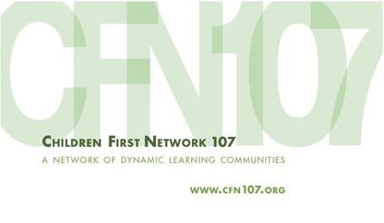
HEDI Practice and Mind Set for Specific Competencies
(45+ mins)

Purpose: To get deeper knowledge about what teacher practice at the Effective and Highly Effective level might look like for specific competencies and the type of mindset a teacher has at these levels. (Note: This is the activity that we did at the summer PD for school leaders).

Materials Needed:
- Power Point?
- TEP Danielson Rubrics
- Markers
- Tape
- Group Chart Paper, Pre-formatted, see example to the right
- Facilitator Chart Paper, Pre-formatted for 1c, below.
- Facilitator Chart Paper, Pre-formatted for 3b, see example below.

Directions:
- Modeling for Part A (5 mins)
  - Explain the 1st step is to record on the chart examples of what teacher practice would look like at each level for the competency assigned.
  - The 2nd step is describe in the second row of the chart the mindset or beliefs a teacher would have to have to achieve at the effective and highly effective levels. Do not fill in the “Mindset” for Ineffective or Developing Practice.
  - Model part of the activity by giving one highly effective practice and one mindset for it. An example for 4E might be:
    - Example of Teacher Practice at Highly Effective: Teacher presents his action research, articles read, lesson plans, students’ work, and his findings at a Network PD where he asks for feedback.
    - Mind Set: Teacher believes that he will improve his practice by conducting action research on his own practice and sharing it with others to get feedback.
- PART A: Group Work (20 mins)
  - Divide participants into groups of 3-5. Give each group a pre-formatted chart paper
  - Ask groups to select a scribe, facilitator, reporter 1, and reporter 2. Reporter 1 will share the examples, Reporter 2 will share the “Underlying skills/mindsets”
  - Facilitator should start the discussion about what might be an example of practice at the ineffective level for the competency assigned.
  - When finished hang the chart paper up
- PART B: Small Group Share Out (8 mins)
  - Each group should have two reporters, one should share the practices and the other the mindsets.
  - The Whole Group Facilitator should chart just the mindsets mentioned into a T chart, see below, capturing the mindsets needed for all competencies at the Effective and Highly Effective level. This is a good chart to hang up in the faculty room or principal’s office as a reminder.
Effective  Underlying Skills/Mindsets | Highly Effective  Underlying Skills/Mindsets
- Part C: Whole Group share Out (10 mins)
  - Ask participants to look at the lists of underlying skills/mindsets and to choose one that resonates with them because it is surprising, it’s something they need to work on, it’s something they do well or believe strongly in.
  - Turn and Talk to a neighbor about what you chose and why
  - Whole Group Share: Ask, “What can we do as a community to nurture these types of skills and mindsets?” OR “Why do these mind sets not exist already?” OR “If they do exist, what’s driving them?”
- Summary: It is easier to cultivate effective practice if you know the mind sets and skills that need to be cultivated.

